|  |  |
| --- | --- |
| Date | 10 November 2023 |
| Team ID | NM2023TMID05035 |
| Project Name | Dissecting the digital landscape: A comprehensive analysis of social media |
| Maximum Marks | 10 Marks |

**Project Report Format**

1. **INTRODUCTION**
   1. Project Overview

Dissecting the Digital Landscape: A Comprehensive Analysis of Social Media" is a research article or paper that provides a detailed and in-depth analysis of various social media platforms, including Facebook, Twitter, Instagram, YouTube, and LinkedIn. The analysis.covers a wide range of topics related to social media, such as the history and evolution of social media, the demographics of social media users, the impact of social media on communication and society, the role of social media in politics and activism, and the challenges and opportunities of social media for businesses and organizations. The paper draws on a wide range of research studies, surveys, and data sources to provide a comprehensive overview of the digital landscape and its implications for individuals, organizations, and society as a whole. Overall, the paper aims to provide a comprehensive and up-to-date understanding of the complex and dynamic world of social media(twitter as an example), and to inform future research, policy, and practice in this rapidly evolving field.

* 1. Purpose:

Audience Understanding:

Social media analysis helps in understanding your audience, including their demographics, preferences, behaviors, and interests. This information is vital for tailoring content and marketing strategies to better engage your target audience.

Brand Reputation Management:

Monitoring social media allows you to track mentions and conversations related to your brand. This helps in managing your online reputation by addressing customer concerns, responding to feedback, and mitigating potential crises.

Competitor Benchmarking:

By analyzing your competitors' social media activities, you can gain insights into their strategies, audience engagement, and performance. This information can inform your own competitive strategies.

1. **LITERATURE SURVEY**
   1. Existing problem

Data Quality:

Social media data can be noisy, with issues like spam, fake accounts, and biased or unrepresentative samples. Ensuring data quality and reliability is a persistent challenge.

Multimodal Data:

Social media content includes text, images, videos, and more. Analyzing multimodal data poses unique challenges, as techniques for one type of data may not directly apply to others.

Algorithm Bias:

Machine learning algorithms used in sentiment analysis and other tasks can be biased, leading to skewed results and reinforcing stereotypes. Addressing algorithmic bias is a critical concern.

* 1. References

"Mining the Social Web" by Matthew A. Russell:

This book offers practical techniques and real-world examples for mining data from various social media platforms using Python.

"Social Media Mining:

An Introduction" by Reza Zafarani, Mohammad Ali Abbasi, and Huan Liu: This text provides a comprehensive overview of social media mining techniques, including data collection, preprocessing, analysis, and applications.

* 1. Problem Statement Definition

Dissecting the Digital Landscape: A Comprehensive Analysis of Social Media" is a research article or paper that provides a detailed and in-depth analysis of various social media platforms, including Facebook, Twitter, Instagram, YouTube, and LinkedIn.

1. **IDEATION & PROPOSED SOLUTION**
   1. Empathy Map Canvas

User Persona:

Begin by defining the user or audience persona you want to analyze on social media. This could be your target customers, followers, or a specific segment.

What They Say:

In this section, list what your audience is saying on social media. Include direct quotes or paraphrases from their posts, comments, and discussions.

What They Do:

Describe the actions and behaviors of your audience on social media. This might include the types of content they share, the platforms they use, and how frequently they engage.

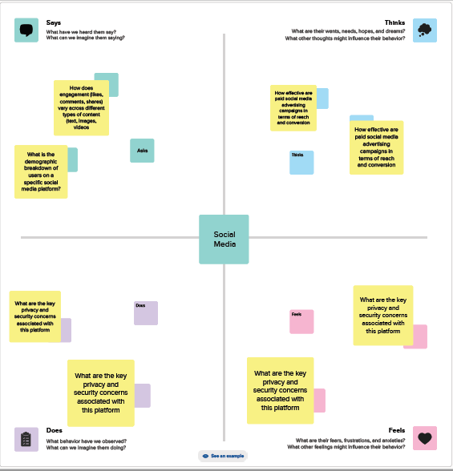

* 1. Ideation & Brainstorming

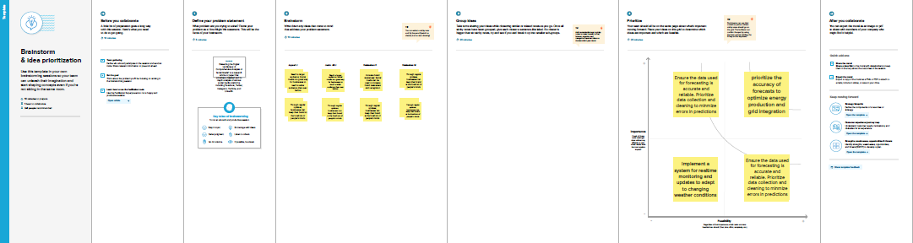

1. **REQUIREMENT ANALYSIS**
   1. Functional requirement

Data Collection:

Ability to collect data from various social media platforms (e.g., Twitter, Facebook, Instagram) through APIs or web scraping.Support for real-time data collection to stay updated with the latest posts and trends.

Data Preprocessing:

Text and content preprocessing to clean and prepare data for analysis.Language detection and translation if analyzing multilingual content.Handling of multimedia content like images and videos.

Sentiment Analysis:

Sentiment classification (positive, negative, neutral).Fine-grained sentiment analysis if needed (e.g., sentiment intensity).

Topic Detection and Trend Analysis:

Topic modeling to identify prevalent themes and discussions.Trend analysis to track how topics evolve over time.

User Profiling:

Audience segmentation and profiling based on demographics and behavior.Identification of key influencers and their characteristics.

* 1. Non-Functional requirements

Performance:

Response Time:

Define acceptable response times for data collection, analysis, and reporting.

Throughput:

Specify the volume of social media data the system should handle per unit of time.

Scalability:

The ability to handle an increasing volume of social media data as your user base grows.

Availability:

Ensure that the system is available and accessible to users as required, including during peak usage times.

Reliability:

The system should operate without frequent interruptions, crashes, or data losses.

Security:

Data Security: Protect user data and sensitive information through encryption, access controls, and secure storage.

User Authentication:

Implement secure user authentication to prevent unauthorized access.

1. **PROJECT DESIGN**
   1. Data Flow Diagrams & User Stories

To accomplish this, we have to complete all the activities listed below,

Define Problem / Problem Understanding

* Specify the business problem
* Business requirements
* Literature Survey
* Social or Business Impact.

Data Collection & Extraction from Database

* Collect the dataset
* Connect IBM DB2 with IBM cognos

Data Preparation

* Prepare the Data for Visualization

Data Visualizations

* No of Unique Visualizations

Dashboard

* Responsive and Design of Dashboard

Story

* No of Scenes of Story

Report

* Creating a report

Performance Testing

* Amount of Data Rendered to DB
* Utilization of Data Filters
* No of Calculation Fields
* No of Visualizations/ Graphs

Web Integration

* Dashboard and Story embed with UI With Flask

Project Demonstration & Documentation

* Record explanation Video for project end to end solution
* Project Documentation-Step by step project development procedure
  1. Solution Architecture

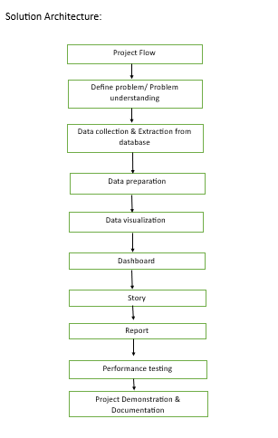

1. **PROJECT PLANNING & SCHEDULING**
   1. Technical Architecture

Data Collection:

* Social Media APIs:

Interface with social media platforms like Twitter, Facebook, Instagram, etc., through their APIs to gather real-time data.

* Web Scraping:

Collect data from websites, forums, and blogs where social media content is discussed.

Data Ingestion:

* Message Queues:

Use message queues like Apache Kafka or RabbitMQ to handle the incoming data and distribute it to various processing components.

* Data Streaming:

For real-time analysis, consider streaming platforms such as Apache Kafka or Apache Flink.

Data Preprocessing:

* Data Cleaning:

Clean and normalize the data to remove noise, handle missing values, and standardize formats.

* Language Detection:

Identify the language of the content for multilingual analysis.

* Text Parsing:

Extract relevant information from text, including hashtags, mentions, URLs, and sentiment analysis.

* 1. Sprint Planning & Estimation

Define User Stories:

Identify the high-level goals for your social media analysis. For example, "As a marketing team, I want to analyze sentiment trends on Twitter to assess the impact of our recent product launch."

Break Down User Stories:

Decompose user stories into smaller, manageable tasks. For the example above, tasks might include data collection, sentiment analysis, and data visualization.

Prioritize Tasks:

Determine the order of importance for each task. Consider dependencies and the value each task brings to the project.

Estimate Effort:

Use relative estimation techniques like story points to estimate the effort required for each task. Assign points based on complexity, uncertainty, and size.

* 1. Sprint Delivery Schedule

1. **CODING & SOLUTIONING (Explain the features added in the project along with code)**
   1. Feature 1

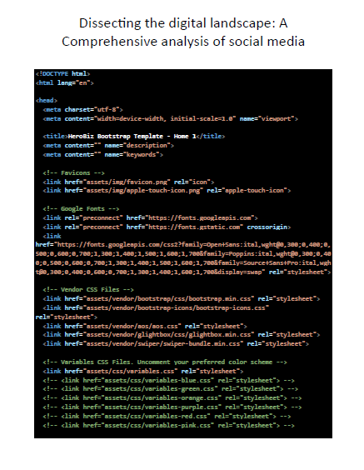

* 1. Feature 2

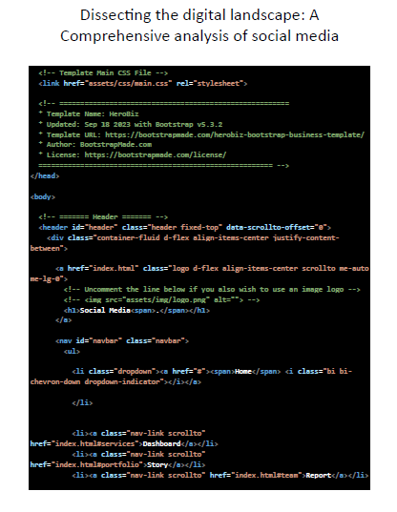

**7.RESULTS**

7.1. Output Screenshots 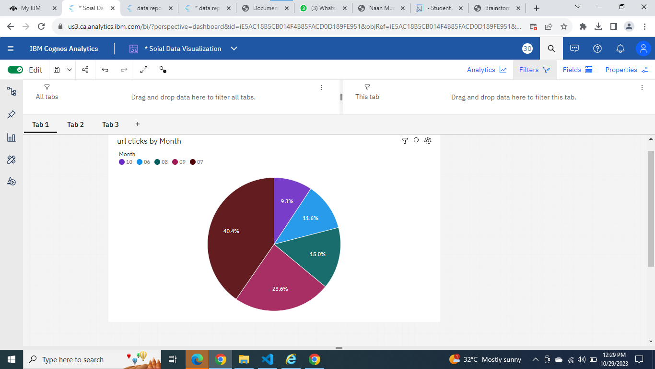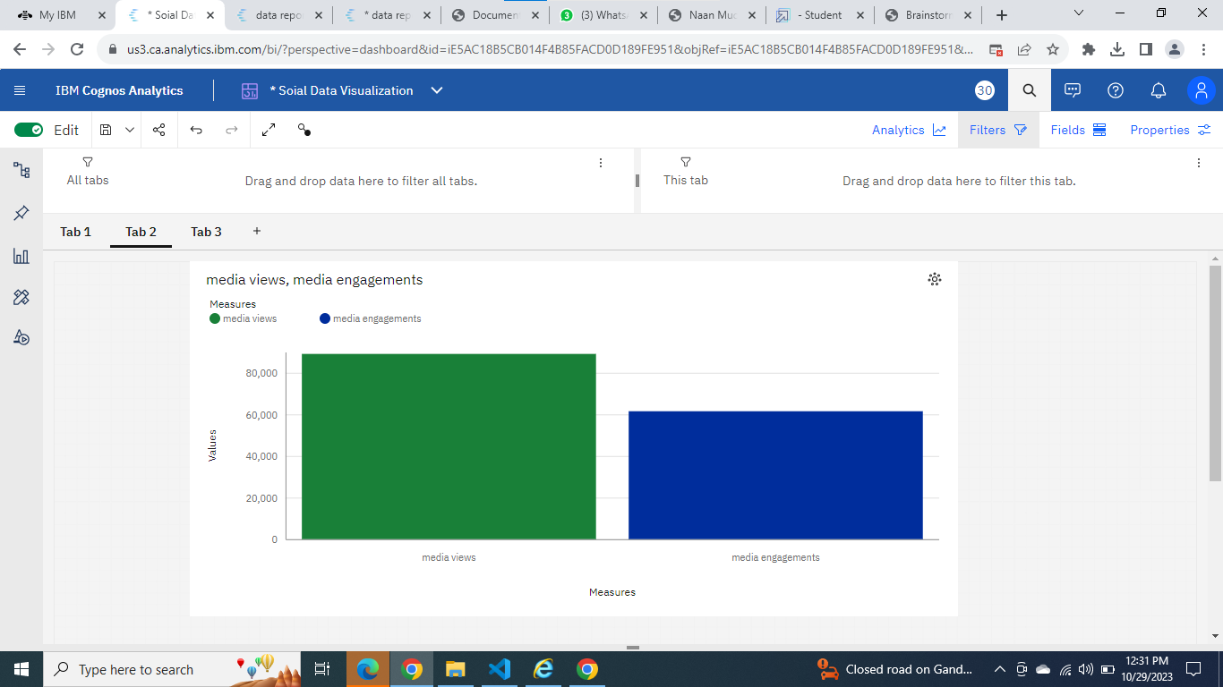

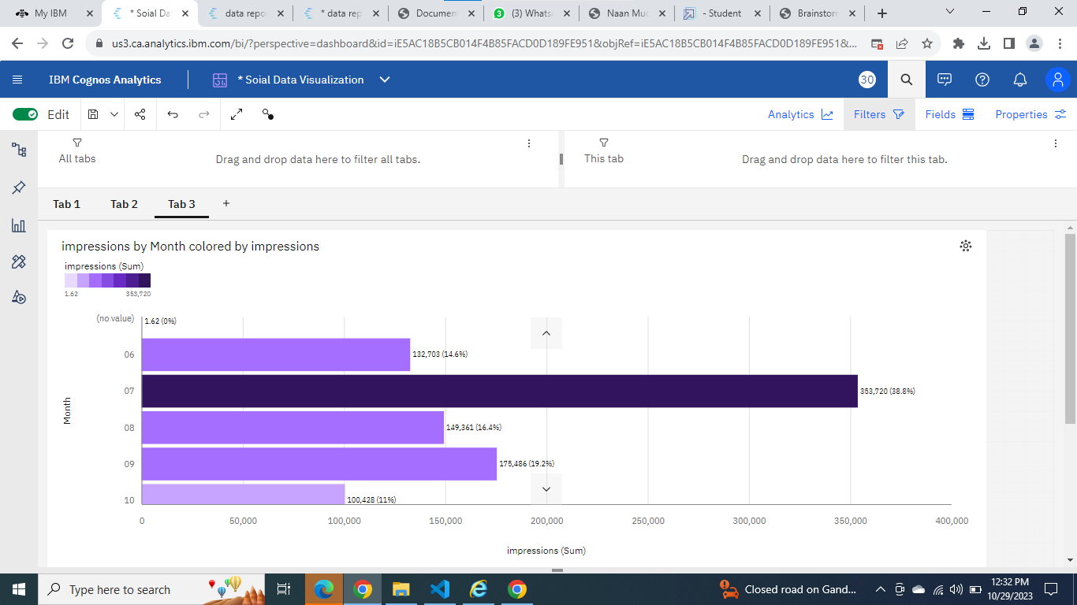

1. **ADVANTAGES & DISADVANTAGES**

**Advantages:**

Real-Time Insights:

Social media analysis provides real-time data, allowing businesses to stay up-to-date with current trends and consumer sentiment.

Market Research:

It offers a cost-effective way to conduct market research, understand consumer preferences, and identify potential opportunities.

Audience Engagement:

Social media analysis helps businesses engage with their audience, respond to comments, and build stronger relationships with customers.

Competitor Analysis:

It allows for monitoring of competitors' activities, helping businesses stay competitive and adapt their strategies.

Brand Monitoring:

Brands can track mentions and sentiment related to their products or services, helping to manage their online reputation.

Product Feedback:

Social media provides a platform for customers to give feedback on products or services, which can be used for product improvement.

**Disadvantages:**

Real-Time Insights:

Social media analysis provides real-time data, allowing businesses to stay up-to-date with current trends and consumer sentiment.

Market Research:

It offers a cost-effective way to conduct market research, understand consumer preferences, and identify potential opportunities.

Audience Engagement:

Social media analysis helps businesses engage with their audience, respond to comments, and build stronger relationships with customers.

Competitor Analysis:

It allows for monitoring of competitors' activities, helping businesses stay competitive and adapt their strategies.

Brand Monitoring:

Brands can track mentions and sentiment related to their products or services, helping to manage their online reputation.

Product Feedback:

Social media provides a platform for customers to give feedback on products or services, which can be used for product improvement.

1. **CONCLUSION**

Real-Time Insights: Social media analysis provides real-time data, allowing businesses to stay up-to-date with current trends and consumer sentiment.

Market Research: It offers a cost-effective way to conduct market research, understand consumer preferences, and identify potential opportunities.

Audience Engagement: Social media analysis helps businesses engage with their audience, respond to comments, and build stronger relationships with customers.

Competitor Analysis: It allows for monitoring of competitors' activities, helping businesses stay competitive and adapt their strategies.

Brand Monitoring: Brands can track mentions and sentiment related to their products or services, helping to manage their online reputation.

Product Feedback: Social media provides a platform for customers to give feedback on products or services, which can be used for product improvement.

1. **FUTURE SCOPE**

Advanced AI and Machine Learning: As AI and machine learning technologies continue to improve, social media analysis will become more accurate and efficient. Natural language processing and sentiment analysis will be more sophisticated.

Predictive Analytics: Social media analysis will move beyond descriptive insights to predictive analytics, helping businesses anticipate trends and consumer behavior.

Deep Learning and Neural Networks: These technologies will enable a deeper understanding of social media data, allowing for more nuanced insights, such as emotion analysis and complex trend predictions.

1. **APPENDIX**

Source Code : <!-- Template Main CSS File -->

<link href="assets/css/main.css" rel="stylesheet">

<!-- =======================================================

* Template Name: HeroBiz

* Updated: Sep 18 2023 with Bootstrap v5.3.2

* Template URL: https://bootstrapmade.com/herobiz-bootstrap-business-template/

* Author: BootstrapMade.com

* License: https://bootstrapmade.com/license/

======================================================== -->

</head>

<body>

<!-- ======= Header ======= -->

<header id="header" class="header fixed-top" data-scrollto-offset="0">

<div class="container-fluid d-flex align-items-center justify-content-between">

<a href="index.html" class="logo d-flex align-items-center scrollto me-auto me-lg-0">

<!-- Uncomment the line below if you also wish to use an image logo -->

<!-- <img src="assets/img/logo.png" alt=""> -->

<h1>Social Media<span>.</span></h1>

</a>

<nav id="navbar" class="navbar">

<ul>

<li class="dropdown"><a href="#"><span>Home</span> <i class="bi bi-chevron-down dropdown-indicator"></i></a>

</li>

<li><a class="nav-link scrollto" href="index.html#services">Dashboard</a></li>

<li><a class="nav-link scrollto" href="index.html#portfolio">Story</a></li>

<li><a class="nav-link scrollto" href="index.html#team">Report</a></li>

GitHub : <https://github.com/kalai123nm/Dissecting-the-Digital-Landscape-A-Comprehensive-Analysis-of-Social-Media.git>

Project dem link:

https://drive.google.com/file/d/1lTgQvAFHNoo9BPa46ukzXviW2C3f6buX/view?usp=drivesdk